**SOFTWARE REQUIREMENT SPECIFICATION (SRS) DOCUMENT**

**STUDENT NAME:** ATHIMANO M J

**ROLL NO:** 7376221CS121

**SEAT NO:** 227

**PROJECT ID:** 27

**DOMAIN:** IQAC

**PROJECT TITLE:** Fitness Certificate

**STACK:**

|  |  |
| --- | --- |
| FRONT END | **React** |
| BACK END | **Java with Spring Boot** |
| DATABASE | **PostgreSQL** |
| API | **RESTful API** |

**1. INTRODUCTION:**

**1.1 Purpose:**

The purpose of this document is to provide a detailed description of the requirements for the development of the Fitness Certificate Portal. This portal aims to facilitate the management of fitness certificates for various venues within the college campus.

**1.2 Scope:**

The Fitness Certificate Portal will allow faculty members to submit details regarding the fitness status of venues within the college. It will also provide administrators with tools to monitor submissions and identify venues requiring attention. The portal will consist of two main modules: Faculty Login and Admin Login.

**1.3 Definitions, Acronyms, and Abbreviations:**

- FC: Fitness Certificate

- NO: Number of Occurrences

**2. DESCRIPTION:**

**2.1 Product Perspective:**

The Fitness Certificate Portal will consist of a frontend developed using React, a backend developed using Spring Boot Java, and a PostgreSQL database. It will also include RESTful APIs to facilitate communication between the frontend and backend.

**2.2 User Classes and Characteristics:**

- Faculty: Users responsible for submitting venue fitness details.

- Admin: Users responsible for managing faculty access, monitoring submissions, and identifying venues requiring attention.

**2.3 Operating Environment:**

The portal will be accessible via modern web browsers on desktop and mobile devices.

**2.4 Design and Implementation Constraints:**

- The frontend must be implemented using React.

- The backend must be implemented using Spring Boot Java.

- The database must be PostgreSQL.

**3. SYSTEM FEATURES:**

**3.1 Faculty Login:**

- Faculty members can log in to the portal.

- They can view a list of venues and their fitness details.

- They can submit fitness details for each venue.

**3.2 Admin Login:**

- Administrators can log in to the portal.

- They can manage faculty user accounts.

- They can view all venue fitness submissions.

- They can identify venues with repeated fitness issues.

**4. EXTERNAL INTERFACE REQUIREMENTS:**

**4.1 User Interfaces:**

The user interfaces will be developed using React for both Faculty and Admin logins. They will include forms for submitting fitness details and tables for viewing venue information.

**4.2 Hardware Interfaces:**

The portal will be accessible via standard web browsers on desktop and mobile devices.

**4.3 Software Interfaces:**

The portal will interact with the PostgreSQL database using Spring Boot Java for backend logic.

**5. NON-FUNCTIONAL REQUIREMENTS:**

**5.1 Performance Requirements:**

The portal must respond to user actions within a reasonable timeframe, even under peak load conditions.

**5.2 Security Requirements:**

User authentication and authorization mechanisms must be implemented to ensure that only authorized users can access the portal and its features.

**5.3 Reliability Requirements:**

The portal must be available and reliable for use by faculty and administrators.

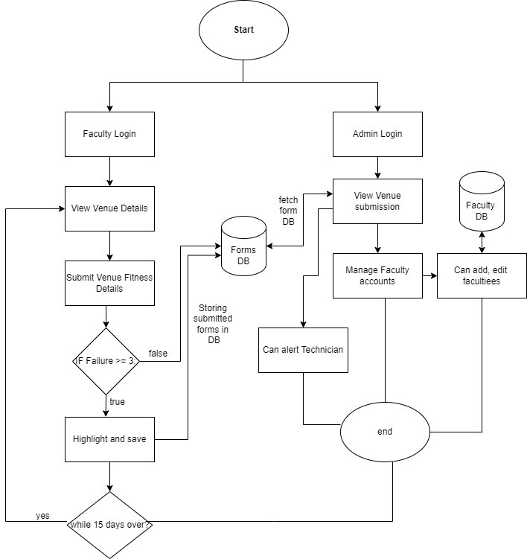**6.FLOWCHART:**